SOFTWARE REQUIREMENTS SPECIFICATION
for
IRO — Issues Reporting Outlet
A Web-Based Platform for Reporting Issues Concerning AAUA Students and Indigenes
Prepared for: CSC426 Weekly Dev — Weekend 3
Course Facilitator: Dr. O. O. Ajayi
Prepared by: Owoyemi Michael Seyi
Matric No.: 220404041

July 10, 2026

Document Status: Final

Table of Contents
Table of Contents 2
1. Introduction 3
1.1 Purpose 3
1.2 Scope 3
1.3 Intended Audience and Reading Suggestions 3
1.4 Definitions, Acronyms and Abbreviations 3
1.5 References 4
1.6 Overview 4
2. Overall Description 5
2.1 Product Perspective 5
2.2 Product Functions 5
2.3 User Classes and Characteristics 5
2.4 Operating Environment 5
2.5 Design and Implementation Constraints 5
2.6 Assumptions and Dependencies 5
3. System Features (Functional Requirements) 7
3.1 FR-01 — Register 7
3.2 FR-02 — Login 7
3.3 FR-03 — Submit Report 7
3.4 FR-04 — Track Status 8
3.5 FR-05 — Announcement 8
3.6 FR-06 — View Reports 8
3.7 FR-07 — Assign Priority 9
3.8 FR-08 — Update Status 9
3.9 FR-09 — Delete Reports 10
3.10 FR-10 — Logout 10
3.11 Non-Functional Requirements 11
3.11.1 Performance 11
3.11.2 Security 11
3.11.3 Usability 11
3.11.4 Reliability and Availability 11
3.11.5 Maintainability 11
3.11.6 Portability 11
4. Use-Case Diagram and Actor Interactions 12
4.1 Actor Summary 12
4.2 Interaction Summary 12
5. External Interface Requirements 13
5.1 User Interfaces 13
5.2 Hardware Interfaces 13
5.3 Software Interfaces 13
5.4 Communication Interfaces 13
6. Other Requirements, Constraints and Assumptions 14
6.1 Regulatory / Institutional Constraints 14
6.2 Project Constraints 14
6.3 Traceability Summary 14
7. Approval 14

1. Introduction

1.1 Purpose
This Software Requirements Specification (SRS) document describes the functional and non-functional requirements for the IRO (Issues Reporting Outlet) system. IRO is a web-based platform commissioned to facilitate the relating and reporting of issues concerning Adekunle Ajasin University (AAUA) students and the indigenes of the surrounding host communities, namely Akungba, Iwaro, Etioro, and Ayegunle. This document is intended for the development team, the course facilitator, and any other stakeholder who requires a clear understanding of what the system is expected to do.

1.2 Scope
IRO will allow registered users (students and indigenes) to submit reports on issues affecting their community, track the status of previously submitted reports, and view announcements published by the administration. Administrators will be able to view all submitted reports, assign a priority level to each report, update the resolution status of reports, and delete reports that are resolved, invalid, or duplicated. The system covers user registration and authentication, report submission and lifecycle management, and administrative oversight of the reporting process. It does not cover offline reporting channels, payment processing, or issue resolution execution (e.g. dispatch of maintenance crews), as these fall outside the boundary of the software system itself.

1.3 Intended Audience and Reading Suggestions
This document is intended for:
- Developers — to understand what functionality must be implemented.
- The course facilitator/assessor — to verify that the delivered system satisfies the stated requirements.
- Project testers — to derive test cases from the functional requirements.
- Future maintainers — to understand system behaviour and constraints.

1.4 Definitions, Acronyms and Abbreviations
Term | Definition
IRO | Issues Reporting Outlet — the name of the system being specified.
AAUA | Adekunle Ajasin University, Akungba-Akoko.
Indigene | A resident/native of the host communities (Akungba, Iwaro, Etioro, Ayegunle).
SRS | Software Requirements Specification.
User | An authenticated student or indigene who submits and tracks issue reports.
Admin | A staff member responsible for managing, prioritising and resolving reports.
UI | User Interface.

1.5 References
- CSC426 Weekly Dev — Weekend 3 assignment brief, Dr. O. O. Ajayi (01/07/26).
- IRO Use-Case Diagram (see Section 4 of this document).
- IRO Ishikawa (Fishbone) Problem Analysis Diagram (companion document, drawn in draw.io).
- IEEE Std 830-1998 — Recommended Practice for Software Requirements Specifications (structural reference).

1.6 Overview
The remainder of this document is organised as follows: Section 2 gives an overall description of the product, its users and constraints. Section 3 details the functional and non-functional requirements. Section 4 presents the use-case diagram and describes actor–system interactions. Section 5 describes external interface requirements, and Section 6 lists system constraints and assumptions.

2. Overall Description

2.1 Product Perspective
IRO is a new, self-contained, web-based system. It is not a modification of an existing system. It interacts with two categories of human actors — Users and Admins — through a browser-based interface, and stores data (accounts, reports, announcements) in a backend database. The diagram below (Figure 1) summarises the major components of the system and how the two actors interact with them.

2.2 Product Functions
At a high level, IRO provides the following functions:
- Account registration and secure login/logout for both Users and Admins.
- Submission of issue reports by Users, with the ability to track the status of each report.
- Publishing of announcements that Users can view.
- Administrative review of all submitted reports, including priority assignment, status updates, and deletion of reports.

2.3 User Classes and Characteristics
User Class | Characteristics
User (Student / Indigene) | General members of the AAUA community and host indigenes. Assumed to have basic computer/smartphone literacy. Primary need is to report issues and follow up on them.
Admin | Staff responsible for triaging and resolving reported issues. Requires elevated access to view, prioritise, update and delete reports.

2.4 Operating Environment
- Client side: any modern web browser (Chrome, Firefox, Edge, Safari) on desktop or mobile.
- Server side: a web server capable of hosting the application backend and a relational/NoSQL database.
- Internet connectivity is required for both Users and Admins to access the system.

2.5 Design and Implementation Constraints
- The system must be delivered as a mini web interface within a limited submission timeframe; complexity is intentionally minimised.
- The system must be version-controlled and hosted on GitHub.
- Only two actor roles are in scope for this release: User and Admin.

2.6 Assumptions and Dependencies
- It is assumed that all users have access to a device with a web browser and an internet connection.
- It is assumed that report data does not include large media attachments beyond what a mini web interface can reasonably handle.
- The system depends on the availability of the hosting environment/database for persistent storage of accounts, reports and announcements.

3. System Features (Functional Requirements)
This section details each functional requirement, derived directly from the use-case diagram in Section 4. Each requirement is uniquely identified (FR-xx) and mapped to the actor(s) who trigger it.

3.1 FR-01 — Register
ID | FR-01
Title | Register
Actor | User
Description | Allows a new User (student or indigene) to create an account on the IRO platform.
Pre-condition | The User does not already have an account.
Trigger | User selects “Register” from the landing page.
Basic Flow | 1. User navigates to the registration page. 2. User supplies required details (e.g. name, email/phone, password, category — student or indigene). 3. System validates the input and checks for duplicate accounts. 4. System creates the account and confirms successful registration.
Post-condition | A new User account is created and the User may proceed to Login.

3.2 FR-02 — Login
ID | FR-02
Title | Login
Actor | User, Admin
Description | Authenticates a registered User or Admin and grants access to role-appropriate features.
Pre-condition | The actor has a valid, registered account.
Trigger | Actor submits credentials on the login page.
Basic Flow | 1. Actor enters username/email and password. 2. System validates credentials against stored records. 3. If valid, system creates an authenticated session and redirects the actor to their dashboard (User dashboard or Admin dashboard). 4. If invalid, system displays an error message and permits retry.
Post-condition | Actor is authenticated and granted access to role-specific functions.

3.3 FR-03 — Submit Report
ID | FR-03
Title | Submit Report
Actor | User
Description | Enables a logged-in User to report an issue concerning AAUA students or indigenes.
Pre-condition | User is logged in.
Trigger | User selects “Submit Report” from their dashboard.
Basic Flow | 1. User opens the report submission form. 2. User enters issue details (title, description, category, location). 3. System validates the input. 4. System stores the report with a default status (e.g. “Pending”) and a timestamp, and associates it with the submitting User. 5. System confirms successful submission.
Post-condition | A new report is created and becomes visible to Admins for review.

3.4 FR-04 — Track Status
ID | FR-04
Title | Track Status
Actor | User
Description | Allows a User to view the current status of the reports they have submitted.
Pre-condition | User is logged in and has at least one submitted report.
Trigger | User selects “Track Status” from their dashboard.
Basic Flow | 1. System retrieves the list of reports submitted by the User. 2. System displays each report alongside its current status (e.g. Pending, In Review, Resolved) and priority, where assigned.
Post-condition | User is informed of the up-to-date status of their submitted reports.

3.5 FR-05 — Announcement
ID | FR-05
Title | Announcement
Actor | User
Description | Allows a User to view announcements published by the Admin.
Pre-condition | User is logged in.
Trigger | User selects “Announcement” from their dashboard.
Basic Flow | 1. System retrieves the list of published announcements. 2. System displays announcements in reverse chronological order.
Post-condition | User is informed of the latest community/system announcements.

3.6 FR-06 — View Reports
ID | FR-06
Title | View Reports
Actor | Admin
Description | Allows the Admin to view all reports submitted by Users.
Pre-condition | Admin is logged in.
Trigger | Admin selects “View Reports” from the admin dashboard.
Basic Flow | 1. System retrieves all submitted reports. 2. System displays reports with details such as reporter, category, description, status and priority. 3. Admin may filter/sort the list (e.g. by status or date).
Post-condition | Admin has full visibility of all reports in the system.

3.7 FR-07 — Assign Priority
ID | FR-07
Title | Assign Priority
Actor | Admin
Description | Allows the Admin to assign a priority level to a report to guide the order of resolution.
Pre-condition | Admin is logged in and viewing a report.
Trigger | Admin selects a report and chooses “Assign Priority”.
Basic Flow | 1. Admin selects a priority level (e.g. Low, Medium, High, Urgent) for the chosen report. 2. System updates and saves the report's priority. 3. System reflects the updated priority wherever the report is displayed.
Post-condition | The report is annotated with a priority level visible to both Admin and the submitting User.

3.8 FR-08 — Update Status
ID | FR-08
Title | Update Status
Actor | Admin
Description | Allows the Admin to change the resolution status of a report as it progresses.
Pre-condition | Admin is logged in and viewing a report.
Trigger | Admin selects a report and chooses “Update Status”.
Basic Flow | 1. Admin selects a new status (e.g. Pending, In Review, Resolved, Rejected). 2. System updates and saves the report's status along with a timestamp. 3. The submitting User can subsequently see the updated status via Track Status.
Post-condition | The report's status is updated and visible to the submitting User.

3.9 FR-09 — Delete Reports
ID | FR-09
Title | Delete Reports
Actor | Admin
Description | Allows the Admin to remove reports that are resolved, invalid, or duplicated.
Pre-condition | Admin is logged in and viewing a report.
Trigger | Admin selects a report and chooses “Delete”.
Basic Flow | 1. Admin selects the report to be removed. 2. System prompts for confirmation. 3. Upon confirmation, system permanently removes the report from the active reports list.
Post-condition | The selected report is removed from the system.

3.10 FR-10 — Logout
ID | FR-10
Title | Logout
Actor | User, Admin
Description | Allows an authenticated actor to securely end their session.
Pre-condition | Actor is logged in.
Trigger | Actor selects “Logout”.
Basic Flow | 1. System terminates the actor's authenticated session. 2. System redirects the actor to the landing/login page.
Post-condition | Actor's session is ended and protected pages become inaccessible until the actor logs in again.

3.11 Non-Functional Requirements
Non-functional requirements describe quality attributes and constraints that the system must satisfy, independent of specific features.

3.11.1 Performance
- The system shall load core pages (login, dashboard, report list) within 3 seconds under normal network conditions.
- The system shall support concurrent access by multiple Users and Admins without noticeable degradation for a mini-deployment scale.

3.11.2 Security
- Passwords shall be stored in hashed (not plain-text) form.
- Only authenticated actors shall access dashboard features; unauthenticated requests shall be redirected to the login page.
- Admin-only functions (View Reports, Assign Priority, Update Status, Delete Reports) shall be restricted to accounts with the Admin role.

3.11.3 Usability
- The interface shall be simple and intuitive, requiring no special training for Users to submit or track reports.
- The system shall provide clear feedback (success/error messages) for all user actions.

3.11.4 Reliability and Availability
- The system shall correctly persist all submitted reports and status changes without data loss.
- The system should aim for high availability appropriate to a web-hosted mini application.

3.11.5 Maintainability
- Source code shall be version-controlled on GitHub with clear commit history.
- The codebase shall be organised to allow future extension (e.g. additional actor roles or report categories).

3.11.6 Portability
- The web interface shall be accessible from any modern browser on desktop and mobile devices without requiring installation.

4. Use-Case Diagram and Actor Interactions
Figure 1 below presents the use-case diagram for IRO, showing the two system actors — User and Admin — and the use cases each can perform. Shared use cases (Login and Logout) are accessible to both actors, while report-submission and tracking functions are exclusive to Users, and report-management functions (viewing, prioritising, updating and deleting reports) are exclusive to Admins.
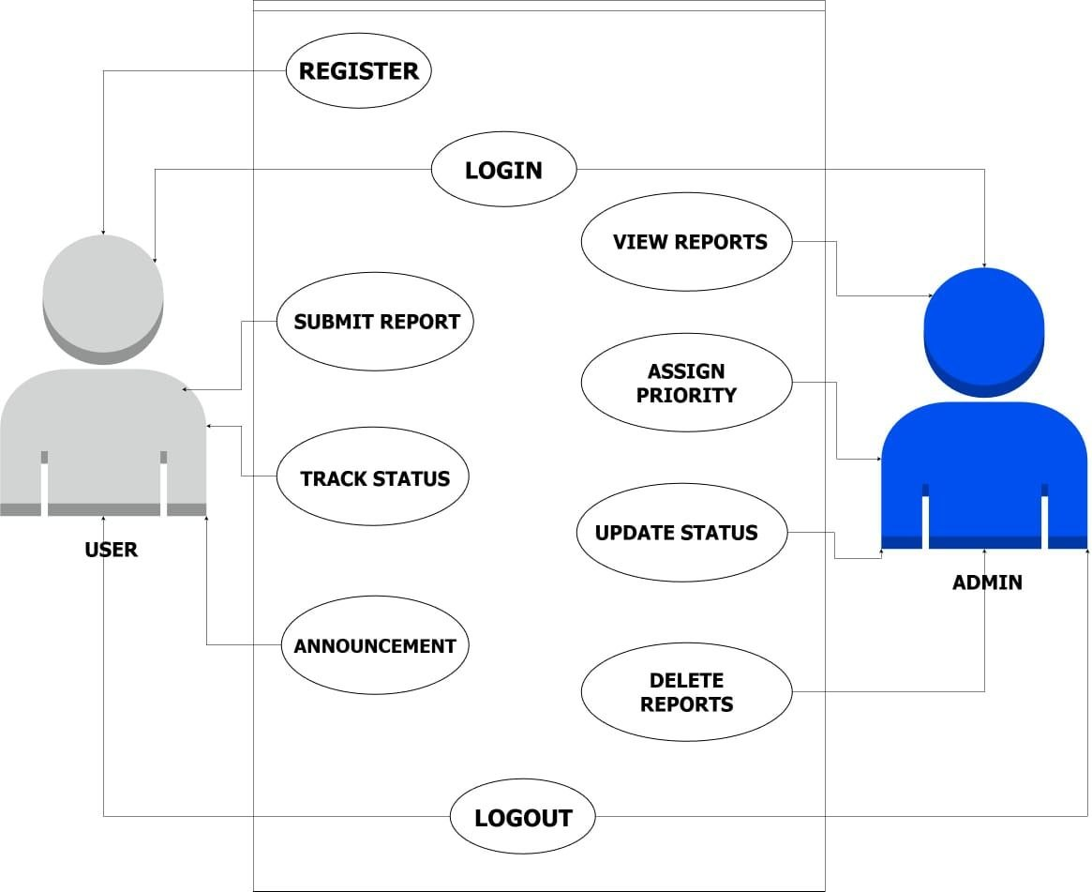
Figure 1: IRO Use-Case Diagram (User and Admin actors)

4.1 Actor Summary
Actor | Use Cases
User | Register, Login, Submit Report, Track Status, Announcement, Logout
Admin | Login, View Reports, Assign Priority, Update Status, Delete Reports, Logout

4.2 Interaction Summary
A User must first Register and Login before submitting a report. Once submitted, a report enters the Admin's queue, where the Admin can View Reports, Assign Priority, and Update Status as the issue progresses toward resolution. The User can independently Track Status at any time to see progress on their own reports, and both User and Admin can view Announcements/Logout as needed. Reports that are resolved, invalid, or duplicated are removed by the Admin through Delete Reports, keeping the active reports list current.

5. External Interface Requirements

5.1 User Interfaces
- Registration and Login pages with input validation and error feedback.
- User Dashboard with navigation to Submit Report, Track Status, and Announcement.
- Admin Dashboard with navigation to View Reports, Assign Priority, Update Status, and Delete Reports.
- Report submission form with fields for title, description, category and location.

5.2 Hardware Interfaces
No special hardware is required. The system runs on standard client devices (desktops, laptops, smartphones) capable of running a modern web browser.

5.3 Software Interfaces
- Web server / application server to host the backend logic.
- Database system for persistent storage of accounts, reports and announcements.
- GitHub for source control and repository hosting of the application and its documentation.

5.4 Communication Interfaces
The system communicates over standard HTTP/HTTPS between the client browser and the web server.

6. Other Requirements, Constraints and Assumptions

6.1 Regulatory / Institutional Constraints
Given the sensitivity of issues that may be reported (concerning both AAUA students and host-community indigenes), the system shall handle reporter identity information responsibly and restrict visibility of full report details to authenticated Admins.

6.2 Project Constraints
- Deliverable timeline: submission deadline of Friday, 10th July 2026.
- The mini web interface is intentionally kept simple to fit within the available submission time.
- Companion artefacts (Google Form community questionnaire, Ishikawa diagram, use-case diagram, and this SRS) are stored in the project's GitHub repository.

6.3 Traceability Summary
Req. ID | Use Case | Primary Actor
FR-01 | Register | User
FR-02 | Login | User, Admin
FR-03 | Submit Report | User
FR-04 | Track Status | User
FR-05 | Announcement | User
FR-06 | View Reports | Admin
FR-07 | Assign Priority | Admin
FR-08 | Update Status | Admin
FR-09 | Delete Reports | Admin
FR-10 | Logout | User, Admin

7. Approval
This document has been prepared to satisfy the SRS deliverable of the CSC426 Weekly Dev — Weekend 3 assignment for the IRO project, and is submitted for review by Dr. O. O. Ajayi.
Prepared by: Idowu Ayomide Oluwatobi
Matric No.: 220404249
Date: ______________________________

